REFLECTIONS ON PROMOTING EQUITABLE AND SOCIALLY JUST MATHEMATICS TEACHING APPROACHES
Pete Wright
University of Dundee, Dundee, Scotland, United Kingdom

Abstract: In this paper I present key findings from four research projects which aimed to promote equitable and socially just mathematics teaching approaches. I outline the design of the projects, all of which were based on a critical model of participatory action research. I draw on the findings from the projects, together with the underlying theories, to identify and exemplify what I believe to be four essential components of socially just mathematics teaching. I offer these insights to readers so that they may judge for themselves the extent to which the findings are transferable to their own contexts and can inform their own practice.

INTRODUCTION
I am truly honoured and excited to be invited to present my thoughts and ideas at the 30th Annual National Congress of The Association for Mathematics Education of South Africa (AMESA). At the same time, I admit to being somewhat nervous about presenting my views on equitable and socially just mathematics education to an AMESA audience. Equity and social justice have been a passion of mine throughout my career in education. My appreciation that political change and education are inseparable was developed through becoming active (as a student and then a young teacher) during the 1980’s in UK-based organisations, such as the Anti-Apartheid Movement and Nicaragua Solidarity Campaign, that aimed to change policies and public opinion at home, as well as to build solidarity with liberation movements around the world. My strong beliefs that education can and should be used as a means for making the world a better place, and that all students should have access to a good quality education regardless of their background, influenced the development of my teaching practice during subsequent years. Becoming a teacher educator in 2011, and completing my doctoral studies in 2015, provided an opportunity to engage more systematically with theory and research around equitable and socially just mathematics teaching. This helped reinforce my commitment to many of the teaching approaches I had previously adopted (at the time because they seemed to resonate with my beliefs and values) as I began to better understand the rationale and justification behind them.
My nervousness stems from an appreciation that what might be applicable to one context (or appropriate in one part of the world) might not be as applicable (or appropriate) in another. Shenton (2004) argues that to promote the ‘transferability’ of research findings, the researcher should provide sufficient contextual details about the research setting, the researcher’s own background and the backgrounds of the research participants. This will then enable the reader to make an informed decision about the extent to which the findings may be relevant to their own situation and inform their own practice. Hence, my aim in this paper is to explain, in as transparent a way as possible, the research that I have carried out in my own context (working mainly with schools and teachers in London and other parts of the UK) and leave it to you to judge the relevance of the findings to developing practice in your own situation.
Shenton (2004) also argues that the researcher’s reflexivity and critical subjectivity should also be clearly communicated in the reporting of research. Over the years, I have grown to appreciate the significant role that power relationships play in maintaining and reproducing inequity and how power is an inherently corrupting force. Indeed, I have admired and respected several political leaders who have stood up to repression, only to be disappointed when, soon after assuming power, they become complicit in maintaining the same repressive systems that they once opposed. I therefore believe it is imperative for those advocating for equity and social justice to acknowledge any privileged positions they hold, and to reflect critically on how power relations may influence their positioning and actions towards others. I have consistently tried to do this as a teacher (in how I relate to students) and as a researcher (in how I relate to participants). For the same reason, it is important to acknowledge my position as a teacher educator and researcher based in a country in which inequity exists between different groups within society, whilst the population (as a whole) benefits disproportionately from an inequitable world governance and trade system.
Having made my positioning clear, in the remainder of this paper, I will present key findings from four research projects I have led which involved working collaboratively with teachers (and in one case teacher educators) to explore how theories relating to equity and social justice in mathematics education can be applied in developing classroom practice. I will draw on underlying theories to present what I believe to be four essential components of socially just mathematics teaching. I will relate each component to relevant findings from the four research projects and exemplify what each might look like in practice. At this point, I would encourage you to pause and try to imagine what a socially just mathematics classroom might look like for you. You might also consider what a socially unjust mathematics classroom might look like. I invite you to write down some of your thoughts in which you distinguish one imaginary classroom from the other.

THE FOUR RESEARCH PROJECTS
All four research projects that I refer to adopted a critical model of participatory action research (PAR) based on a series of plan-teach-evaluate cycles. PAR involves carrying out research with teachers, as collaborative partners, rather than carrying out research on teachers, as subjects (Wright, 2021). It recognises that both academic researchers (with their research expertise) and teacher researchers (with their in-depth knowledge of the classroom context and their learners) have essential and complementary roles to play in research that aims to bring about positive social change. Because PAR pays closer attention to teachers’ perspectives and classroom constraints, it is more likely to generate findings of greater interest and relevance to other practitioners.
The critical model of PAR (Skovsmose & Borba, 2004) assumes that the current situation (CS), in this case existing mathematics teaching practice, should not be taken as given. The imagined situation (IS) is an alternative vision of what could be, in this case an equitable and socially just mathematics classroom, identified by drawing on research literature and previous experiences. The arranged situation (AS) is where an attempt is made to put some aspect(s) of the imagined situation into practice, taking account of the realities and constraints of the current situation. In this case, the imaginary situation involved the teacher researchers designing, teaching and evaluating research lessons in which new ideas, activities and strategies were tried out. This, in turn, led to changes in their thinking and classroom practice and hence a modified current situation, feeding into the next PAR cycle (see Figure 1 below).
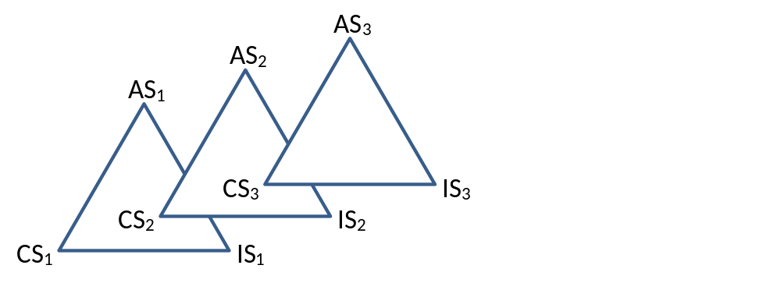

Figure 1: Critical model of PAR with 3 cycles (Skovsmose & Borba, 2004, p. 221)
All four research projects involved establishing a research team of teacher researchers and academic researchers. Research team meetings focused on engaging with research literature relevant to socially just mathematics teaching, designing research lessons and data collection tools (such as student surveys, interviews and video recordings) which were used to evaluate the lessons (Wright, 2024a). The involvement of teacher researchers in designing as well as implementing data collection tools was a key characteristic of the research projects (Wright, 2024a). This contributed towards greater levels of reliability of student data, since relationships of trust were already established between teachers and students. Further data were collected through recording reflective discussions during research team meetings and through interviews with teacher researchers, which were designed to capture their experiences of participating in the projects. Thematic analyses were then carried out on the data (Braun & Clarke, 2022).
The Teaching Maths for social Justice (TMSJ) research project was carried out as part of my doctoral studies conducted from 2013 to 2014 (Wright, 2016a; Wright, 2017). I collaborated with five mathematics teachers in four ethnically diverse secondary (age 11-16) schools in London within areas of relatively high levels of socio-economic deprivation. They were all in their second year as qualified teachers having previously completed the same pre-service teacher education course that I taught on at University College London Institute of Education. The research focused on exploring strategies for translating theories relating to social justice into classroom practice through designing, trialling and evaluating a series of activities. The findings demonstrated how, through critically reflecting on existing practice within a community of inquiry, teachers can transform their thinking and classroom practice. They began to recognise the need to tackle systemic inequities by challenging existing structures and discourses, including around the grouping of students by prior attainment, and by promoting progressive pedagogies that engage all students and develop students’ agency.
The Visible Maths Pedagogy (VMP) project was a collaboration with two teacher researchers from 2017 to 2019 in an ethnically diverse secondary school in London (Wright, Fejzo, & Carvalho, 2022). Both were experienced teachers who I had previously worked with as a student teacher and mentor. The project aimed to develop strategies that would enable all students to recognise their teacher’s intentions when adopting progressive teaching approaches. These approaches were already well established within the mathematics department, however there were concerns that some students, particularly those from marginalised groups, found it difficult to engage with them. The findings demonstrated how teachers can help all learners to develop a greater appreciation of their pedagogic rationale through prompting open discussions with students around the reasons for using their teaching approaches. This, in turn, helps all students achieve greater success when experiencing progressive pedagogies.
The Primary Maths and Social Justice (PMSJ) research project was a collaboration with two co-researchers, six teacher researchers and six other teachers from 2021 to 2023 in two culturally diverse primary (age 5-11) schools in London (Wright, Kelly, & Hilton, 2024). It is common practice in primary schools in England for students to spend significant amounts of time exploring social justice issues (such as climate change or racism) through cross-curricular projects. In contrast, mathematics is commonly taught as a discrete subject, and students often struggle to apply the mathematics they learn in these lessons to solving real-life problems. The project explored how teachers can bridge this gap by making stronger connections between social justice issues tackled in cross-curricular projects and mathematics learning. The findings demonstrated how teachers can help students to develop a greater capacity to use the mathematical knowledge they have previously learned in constructing collective arguments for change in relation to social justice issues (referred to as socio-mathematical agency). In doing so, students (and teachers) developed more positive dispositions towards mathematics as they began to appreciate how it can be applied in more meaningful and relevant ways to their own interests and experiences.
The Promoting Socially Just Mathematics Teaching (PSJMT) research project is an ongoing collaboration with 12 colleagues from different universities across England and Scotland that began in 2024. The project aims to explore how mathematics teacher educators can promote socially just pedagogies and practices amongst the student teachers and experienced practitioners they work with. The outcomes include designing a series of professional development workshops for teachers, which are freely accessible (currently in draft form) at www.mathsocialjustice.org/prof-dev. Initial findings suggest that most teachers are enthusiastic and willing to engage with issues of equity and social justice in teaching mathematics, although pressures and constraints they face in the classroom often result in them losing sight of these aims. Reflecting critically on equity and social justice, in particular how these relate to issues which are a key priority for schools (including inclusion, engagement and problem solving), can enable teachers to better understand and overcome these constraints.
Having presented key findings from the four research projects, I will now outline how these findings, and the theories which informed the design of the projects, relate to four essential components of socially just mathematics teaching which I have identified.

PROGRESSIVE PEDAGOGIES
By progressive pedagogies I mean adopting teaching approaches that encourage students to tackle open-ended tasks, to discuss ideas and share different methods, and to collaborate in solving mathematical problems. Gutstein (2006) highlights how such approaches enable learners to acquire mathematical power by developing their agency in applying mathematical ideas and processes to solve real-life problems. Whilst mastering and practising mathematical procedures is important, experiencing how to pose questions, make conjectures and identify which procedures to use in unfamiliar situations are essential if students are to make effective use of the mathematics they learn outside of school. Worryingly, there has been a recent resurgence in England of teacher-led pedagogies, led by advocates of Direct Instruction, who argue that knowledge is inherently powerful regardless of the learner’s agency in using it (Wright, Fejzo, & Carvalho, 2022). They draw on Bernstein’s (2000) argument that students from disadvantaged backgrounds, due to their upbringing, are less able to recognise how to respond appropriately to (less-structured) progressive pedagogies and hence achieve less success when they are employed. Such teacher-led approaches result in increasing levels of anxiety and alienation amongst students as they perceive the mathematics they learn as lacking purpose and meaning (Williams & Choudry, 2016).
The VMP project succeeded to some extent in tackling the problem of students (particularly those from disadvantaged backgrounds) misinterpreting the intentions of the teacher by making the rationale for employing progressive pedagogies more explicit to learners. This was achieved through various strategies including holding discussions with students in which this rationale was the explicit focus, for example by asking: “Why do you think I asked you to …?”. The Fraction Flags activity (see Figure 2) serves to exemplify this approach (Wright, 2024a). I would encourage you to pause reading this paper whilst you discuss the three prompts below with a colleague.


Figure 2: Flags of Czechia and Seychelles
- Discuss in small groups what fraction of each flag is coloured blue, white and red.
- Find more than one way of explaining your answers.
- Make notes on somebody else’s reasoning ready to present these to the whole class.
Students were asked to work on the Fractions Flags activity in small groups. They were encouraged to share ideas with each other and to come up with their own questions to ask. Once they had found one method of finding the answers, they were encouraged to look for alternative methods. The focus was on explaining and justifying their solutions rather than finding the correct answer. When required, the teacher would intervene with prompt questions such as: “What information do you need to know to be able to work it out?” After most groups had found several methods for finding the solutions, some students were asked to present another student’s reasoning to the rest of the class.
After the activity was completed, the teacher then tried out a strategy for making the teaching rationale more explicit to learners, in this case facilitating a discussion with the whole class by using the prompt question: “Why do you think I asked you to present somebody else’s reasoning?” The project’s findings suggested that some students initially misinterpreted the teacher’s intentions, for example, the following two responses suggested students believed the teacher was merely enforcing listening: “To see if you’re listening to your friend.” … “Make sure you’re listening and learning.”
Other responses from students suggested reasons that more closely reflected the teacher’s primary reasons, which were to encourage students to share ideas with each other and to engage with and learn from other people’s methods: “So that we understand other’s point [of] view.” … “Because you can get two different perspective[s] and it may help you finalise your idea.”
Over the course of the project, teacher researchers reported an increasing proportion of students who were able to correctly identify the teacher’s reasons for adopting specific teaching approaches. This was particularly evident for those from marginalized groups. There was also evidence to suggest that students were better able to respond appropriately and achieve success when experiencing progressive teaching approaches. During an interview with one of the teacher researchers, Keira (a female student of Afro-Caribbean heritage from a family with low socio-economic status) describes how engaging with another strategy for making the teacher’s pedagogic rationale more explicit (in this case a card sort) helped make the purpose of learning clearer to her:
“Because it helps us, like, understand more why we do it, because … some people would be like ‘Ah, what is this going to help us with in the future?’, and stuff like this. And it would just help you, like, understand more, and like why we’re doing this, why we’re learning this, why it’s going to help us.”

MEANINGFUL INQUIRY
Gutstein (2006) applies Freire’s (1974) model of education for critical consciousness in arguing that students should be encouraged to use mathematics to explore issues of inequity and injustice which they encounter in their own lives and in society more widely. As well as highlighting its problematic nature, for example in contributing towards economic crises, Skovsmose (2024) emphasises how mathematics can also be used as a critical tool in struggles for social justice. Mathematical models can be used to monitor and report the extent of climate change or to measure and report inequalities within society (see for example the Lorenz Curve and Gini Coefficient in Figure 3).
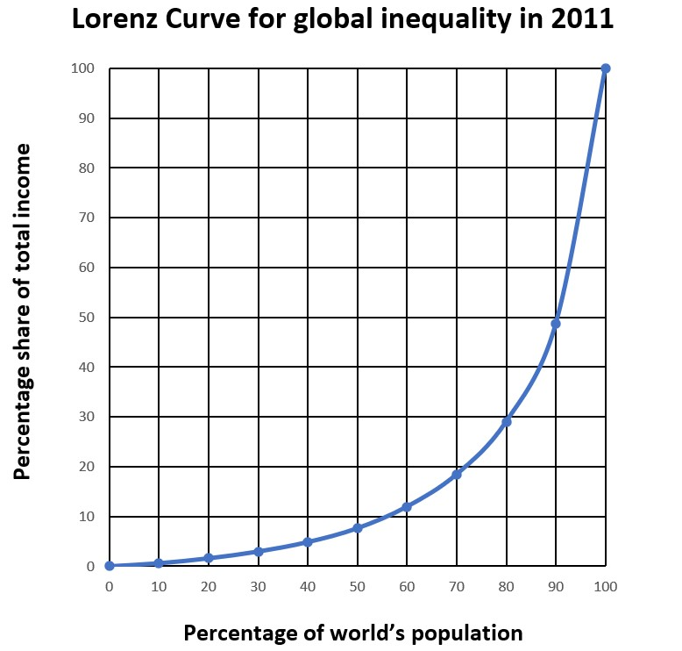 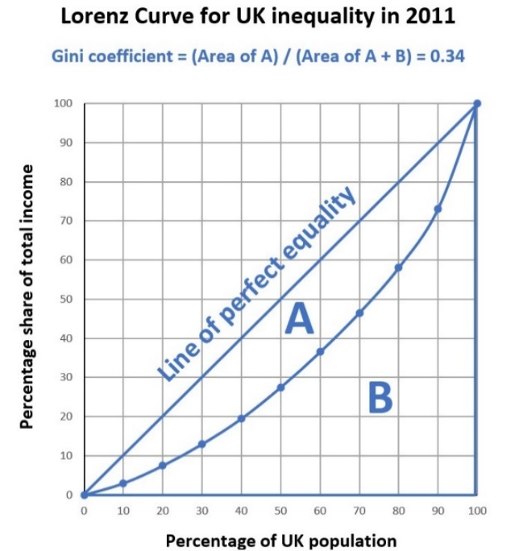Figure 3: Lorenz curve and Gini coefficient for 2011
The findings of the TMSJ and PMSJ projects demonstrated how secondary and primary students (respectively) respond positively when encouraged to use mathematics to explore real-life social justice issues. In both cases, students’ levels of engagement increased dramatically, particularly amongst those who had become disengaged or alienated from the subject, as they began to appreciate the relevance of mathematics to social issues which they experienced directly or felt passionately about. Whilst students commonly encountered word problems in mathematics lessons, the real-life contexts were often superficial in nature and of little interest to them. The teacher researchers noticed how students (even the youngest) care passionately about issues of fairness and social justice and were keen to explore connections between these and mathematics.
“I tried a few things with my bottom set and their motivation has just been so high in those particular lessons that I’ve had to very rarely like tell them to get on with things or to do things.” (Anna, teacher researcher, TMSJ project)
“In general, I do not enjoy maths as I think I’m not very good at it. Today I enjoyed the maths lesson as I enjoyed finding out about fair trade and I liked seeing all the statistics of the money different people make from a bar of chocolate.” (Year 9/age 13-14 student, TMSJ project).
“The children were very engaged. I think the fact that they were attributing it to a real-life problem or challenge. So, they really took ownership over setting their own investigations and then understood very much how maths can be related to real life.” (Layla, Year 6/age 10-11 teacher researcher, PMSJ project)
However, teachers also faced significant constraints in introducing these ideas into their mathematics lessons. These included the prescriptive nature of the mathematics curriculum, with large amounts of content to be covered, and limited time for planning, particularly as there were very few existing resources to draw from. This required genuine links to be established between social justice issues and mathematical content. For instance, calculating the Gini coefficient (see Figure 3) involves finding an irregular area between the (straight) line of perfect equality and the Lorenz curve. This is a very rich mathematical task which allows for various ideas to be applied, including approximating the area either by counting whole and/or part squares or by using rectangles, triangles and trapezia. I invite you to pause and have a go at this for yourself.
These constraints were to some extent resolved by collaboratively planning and sharing of resources between members of the research teams. The teacher researchers in both projects reported how the mutual support provided by other members of the research team encouraged them to try out new (and sometimes risky) ideas with their classes:
“It’s given me the confidence to step off the scheme of work treadmill, of getting through different topics or chapters, and actually saying: ‘Well, these topics, say cumulative frequency, or percentages, I can fit these within a project on something to do with these kids’ world, or to do with our world as a whole.” (Brian, teacher researcher, TMSJ project)
“The collaboration, the meetings with other teachers. I liked it when we shared all ideas, and we heard what other year groups were doing … If you're trying to do something new, you just need to get a group of like-minded people, who will have different skill sets, to kind of work with each other, but also challenge and suggest new ideas.” (Rose, Year 5/age 9-10 teacher researcher, PMSJ project)
Both the TMSJ and PMSJ projects generated teaching ideas and resources which have been shared more widely through two publications (see Wright, 2016b; Cotton, Jagdev, Kaur, & Wright, 2024). Note some of these (and similar) teaching ideas are freely available via the TMSJN website www.mathsocialjustice.org (see Activities and Resources pages, and other project websites which can be found via the Links page).

COLLECTIVE AGENCY
There have been several calls recently for more humanistic school curricula that cultivate the critical understanding and collective knowledge needed to enable future generations to address the social, economic and environmental challenges facing global society (OECD, 2018; UNESCO, 2015). This requires learners to develop not only greater understanding of social justice issues, but also agency in generating arguments for bringing about change for the better. Mathematics can play a key role in supporting such arguments. In cases where mathematics is used to solve problems in real life, this is usually done by people working in teams rather than as individuals. However, many mathematics lessons are characterised by students working individually on closed tasks without the opportunity to develop collective agency. We highlighted in a previous paper the need for students to develop socio-mathematical agency, defined as the capacity to use mathematics effectively in arguing collectively for social change (Wright, Kelly, & Hilton, 2024). The findings from the TMSJ and PMSJ projects demonstrated how this might be achieved in practice.
During the TMSJ project, teacher researchers developed the Making a Change activity which involved students working in small groups, choosing a social justice issue of interest to them, researching it, and using mathematics to construct an argument in support of a change they would like to see made. They were then asked to present their argument to the rest of the class. Groups chose a range of issues to explore including human trafficking, food distribution, discrimination and the death penalty. The PowerPoint presentations created by the groups to summarise their arguments can be accessed at: www.maths-socialjustice.weebly.com/project-teaching-resources.html. This activity generated very high levels of excitement and engagement amongst students, including those who had previously shown little interest in mathematics:
“They were all so passionate about the things they were presenting about, was the key thing, and the fact that they got to actually tell everyone what they found out.” (Anna, teacher researcher, TMSJ project)
In the PMSJ project, teacher researchers designed several activities including one that prompted students to consider how to use counters in deciding collectively how to arrive at a fair choice, for example, when deciding which fun activity to choose as a class reward for the hard work done during the week. Students were divided into groups and each group was given 10 counters. They were given time to discuss how to allocate their counters to the available options. When all groups had decided, they were invited to place their counters on a board such as that shown in Figure 4.
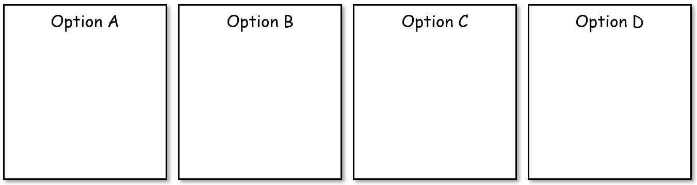

Figure 4: Making a fair choice
Students were then asked to reflect on the fairness of the choice made by the class, using the following prompt questions (see Wright, 2023):
- How did you feel about the result? Do you think your view was taken into account? What about other people’s views? Why?
- How big should the groups be? Why? How many counters should be allocated to each group? What if the groups were different sizes?
- How many counters should each group allocate to their first/second/third/fourth choice? Why? How should we use the results to make a decision? Why?
- What other questions should we consider?
The findings demonstrate how students (regardless of age) can develop socio-mathematical agency by working collaboratively to generate an argument for change:
“I think the major impact is just that they're actually learning how to give an opinion … And understanding that they can apply maths to situations that are not just in the classroom, and things that affect them.” (Emma, Year 1/age 5-6 teacher researcher, PMSJ project)
“And then they worked with their talk partner to talk about their views. And there was some quite heated discussion amongst them. And at that point, they were really keen then to come up with some different ideas, which they thought might be fairer.” (Kate, Year 1/age 5-6 teacher researcher, PMSJ project)

CHALLENGING MYTHS AND DISCOURSES
Bourdieu’s theory of reproduction outlines how schools contribute towards maintaining inequitable power relations between different groups in society through assigning greater value to the cultural resources acquired by children from more privileged groups (Bourdieu & Passeron, 1990). This systemic inequity is concealed by presenting the school as a level playing field in which success is attributed to innate ability rather than the systemic advantage afforded to some children. Mathematics plays a key role in this reproductive process, with a persistent and strong correlation between socio-economic status and mathematical attainment, whilst mathematics qualifications determine access to higher-status university courses and better-paid employment (Wright, 2016a). Skovsmose (2011) highlights the need for both teachers and students to develop a critical understanding of mathematics and to reflect on questions relating to the nature of the subject, its purpose and its position in society. Teachers and students should engage in dialogue and challenge common myths and discourses, including claims that mathematics is culture and value-free, is all about right/wrong answers, and that mathematical ability is innate (Coles & Sinclair, 2022).
All four projects demonstrated how critical reflection, which was an essential component of all four research designs, can lead to a greater willingness of teachers to question their own prior assumptions and challenge discourses they encounter in schools. This was a key focus of the PSJMT project. The professional development resources that were developed incorporate opportunities for teachers to reflect on their initial thinking and, after engaging with the theories presented and with the classroom activities modelled during the workshop, to reflect on how their thinking has changed over the course of the workshop (see example slides from the Socially just approaches to problem solving in mathematics workshop in Figure 5).
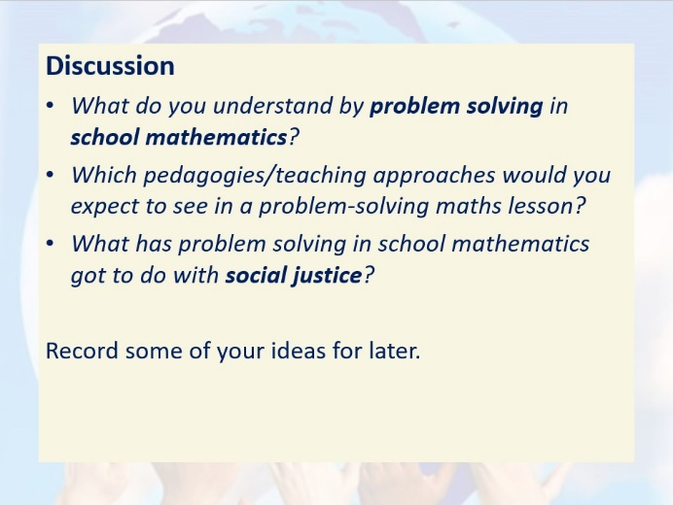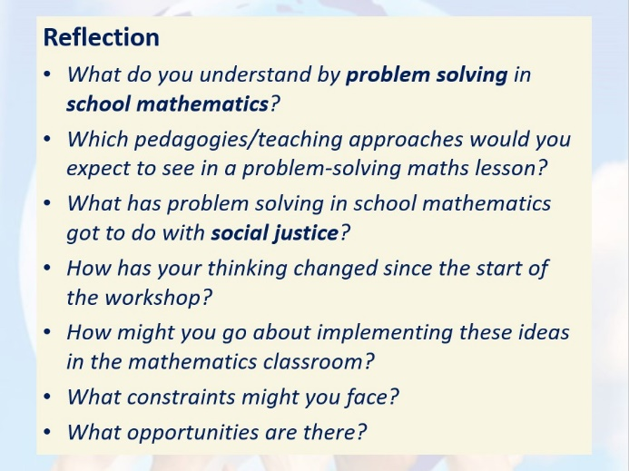

Figure 5: PSJMT workshop – initial Discussion and final Reflection slides
At this point, I would encourage you to pause and to reflect on your earlier thoughts about what distinguishes a socially just from a socially unjust mathematics classroom (which you were invited to record at the start of this paper). Consider how your thinking has changed having engaged with this paper (mirroring the process that teachers go through when attending the PSJMT professional development workshops).

IMPLICATIONS FOR PRACTICE
I have presented the findings from four research projects and related these to what I believe to be four essential components of socially just mathematics teaching, which are summarised below. I invite you to reflect on the findings from these projects and to judge the extent to which the findings are transferable to your own context. I hope that this paper has helped you to reflect in some meaningful way on your practice.
Essential components of socially just mathematics teaching (Wright, 2024b, p. 26):
- Employ collaborative, discursive, problem-solving, and problem-posing pedagogies which promote mathematical sense-making and the engagement of all learners with mathematics.
- Promote mathematical inquiries that resonate with learners’ real-life experiences and that help them develop greater understanding of their social, cultural, political, and economic situations.
- Facilitate mathematical investigations that develop learners’ individual and collective agency, enabling them to take part in future social action for the public good.
- Challenge common myths surrounding school mathematics, expose processes that lead to the marginalisation of some learners, and open up to scrutiny what it means to be successful.

REFERENCES (sources marked * are available open access)
Bernstein, B. (2000). Pedagogy, symbolic control and identity: Theory, research, critique (Revised ed.). Lanham, Maryland: Rowman & Littlefield Publishers.
Bourdieu, P., & Passeron, J.-C. (1990). Reproduction in education, society and culture (2nd ed.). London: Sage.
Braun, V., & Clarke, V. (2022). Thematic analysis: A practical guide. Los Angeles: Sage.
Coles, A., & Sinclair, N. (2022). I Can't Do Maths! Why children say it and how to make a difference. London: Bloomsbury.
Cotton, T., Jagdev, M. K., Kaur, B., & Wright, P. (2024). Towards a socially just mathematics curriculum: A theoretical and practical approach. London: Routledge.
Freire, P. (1974). Education for critical consciousness. London: Sheed & Ward.
Gutstein, E. (2006). Reading and writing the world with mathematics: Toward a pedagogy for social justice. New York: Routledge.
*OECD. (2018). The Future of education and skills: Education 2030. Paris: Organisation for Economic Co-operation and Development (OECD). Retrieved from https://www.oecd.org/content/dam/oecd/en/publications/reports/2018/06/
the-future-of-education-and-skills_5424dd26/54ac7020-en.pdf
Shenton, A. K. (2004). Strategies for ensuring trustworthiness in qualitative research projects. Education for Information, 22, 63-75. https://doi.org/10.3233/EFI-2004-22201
Skovsmose, O. (2011). An invitation to critical mathematics education. Rotterdam: Sense Publishers.
*Skovsmose, O. (2024). A critical conception of mathematics. In B. Greer, D. Kollosche, & O. Skovsmose, Breaking images: Iconoclastic analyses of mathematics and its education (pp. 213-234). Open Book Publishers. Retrieved from https://www.openbookpublishers.com/books/10.11647/OBP.0407
Skovsmose, O., & Borba, M. (2004). Research methodology and critical mathematics education. In P. Valero, & R. Zevenbergen (Eds.), Researching the socio-political dimensions of mathematics education (pp. 207-226). Dordrecht: Kluwer Academic Publishers.
*UNESCO. (2015). Rethinking education: Towards a global common good? Paris: United Nations Educational, Scientific and Cultural Organisation. Retrieved from https://unesdoc.unesco.org/ark:/48223/pf0000232652
Williams, J., & Choudry, S. (2016). Mathematics capital in the educational field: Beyond Bourdieu. Research in Mathematics Education, 18(1), 3-21. https://doi.org/10.1080/14794802.2016.1141113
*Wright, P. (2016a). Social justice in the mathematics classroom. London Review of Education, 14(2), 104-118. https://doi.org/10.18546/LRE.14.2.07
Wright, P. (2016b). Teaching mathematics for social justice: Meaningful projects for the secondary mathematics classroom. Derby: Association of Teachers of Mathematics.
*Wright, P. (2017). Critical relationships between teachers and learners of school mathematics. Pedagogy, Culture and Society, 25(4), 515-530. https://doi.org/10.1080/14681366.2017.1285345
*Wright, P. (2021). Transforming mathematics classroom practice through participatory action research. Journal of Mathematics Teacher Education, 24(2), 155-177. https://doi.org/10.1007/s10857-019-09452-1
*Wright, P. (2023). Mathematics and social justice . Scottish Mathematical Council Journal, 53, 31-36. Retrieved from https://drive.google.com/file/d/1ItRS1_
QXl91b4WVfuZRgU6LGOfci22Ns/view
*Wright, P. (2024a). Raising mathematical achievement and engagement through practitioner enquiry and action research. Scottish Mathematical Council Journal, 54, 43-45. Retrieved from https://drive.google.com/file/d/
1KF7V0jORIoWTd4G8honR6DSvjyqjzueb/view
Wright, P. (2024b). The mathematics curriculum and concerns for social justice. In T. Cotton, M. K. Jagdev, B. Kaur, & P. Wright, Towards a socially just mathematics curriculum (pp. 19-31). London: Routledge.
*Wright, P., Fejzo, A., & Carvalho, T. (2022). Progressive pedagogies made visible: Implications for equitable mathematics teaching. The Curriculum Journal, 33(1), 25-41. https://doi.org/10.1002/curj.122
*Wright, P., Kelly, J., & Hilton, C. (2024). Mathematics teachers and learners as collective agents of change. London Review of Education, 22(1), 1-15. https://doi.org/10.14324/LRE.22.1.22

