Workshop 1:
Socially just approaches to inclusion in mathematics
This is one of a series of professional development workshops on promoting socially just mathematics teaching developed by the members of the Teaching Maths for Social Justice Network (TMSJN) and freely available via the network’s website: www.mathsocialjustice.org
The development of this workshop was supported by funding from the BERA Small Grant Fund awarded to Pete Wright and a team of co-researchers from the TMSJN.

Guidance notes for facilitators
These guidance notes are written to accompany the ‘Socially just approaches to inclusion in mathematics’ PowerPoint presentation available on the TMSJN website. They are designed to support a facilitator in leading a workshop with a group of teachers. The guidance notes are both detailed and flexible, which means they are suitable for a range of facilitators, including the experienced teacher educator working with a group of student teachers, to a teacher with a particular interest in mathematics and social justice who wishes to run a professional development session for other teachers in their department or school. Some (but not all) of the notes are duplicated in the notes accompanying each slide within the PowerPoint presentation.

Session design:
- The session is designed to be a workshop lasting approximately 90 minutes in which participants are encouraged to play an active role by sharing and discussing ideas.
- It is aimed at teachers of mathematics across primary and secondary phases, including student teachers and experienced teachers engaging with the ideas for the first time (although facilitators may need to tailor the workshop to the needs of their participants).
- It draws on design principles agreed at a Critical Mathematics Education Working Group meeting held at the BSRLM conference in June 2024 including the following:
  - Facilitate critical reflection on practice through challenging discourses.
  - Support teachers in putting socially just maths teaching ideas into practice.
- The activities are an important aspect of the workshop as they provide an opportunity to link theory, critical reflection and practice. Facilitators should think carefully about how to model socially just practice when introducing the activities and be ready to highlight the characteristics of the activities that help to facilitate socially just teaching. Allow participants sufficient time to engage with the activities (to inform discussion) whilst ensuring there is also enough time allocated to the reflective discussions.

Resources:
- Tables arranged in café style to encourage small group and whole group discussion.
- Accompanying PowerPoint presentation (projected onto screen).
- Appendix 1 can be used as a card sort to facilitate the discussion on slide 6.
- Appendices 2 and 3 provide printable versions of the activities on slides 8 and 9, 10 and 11 (useful for accessibility/visibility and to allow participants to annotate diagrams).
- Appendix 4 provides a printable version of the diagrams from the activities on slides 15 and 16 (needs to be used in conjunction with guidance on slides).

Introduction:
- Emphasise that this workshop, and others in the series, are free to download - they are accompanied by detailed/flexible notes for facilitators [slide1].
- Outline features of the workshop [slide 2].

Initial discussions:
- Use the quotes on slides 3 and 4 (take brief comments only) to draw out links between inclusion and social justice.
  - Emphasise that these quotes offer different perspectives to prompt discussion and are not meant to be definitive answers.
  - Note the following terms are also considered to relate closely to what we mean by ‘inclusion’: differentiation, adaptive teaching, meeting the needs of all learners, attainment grouping, scaffolding, additional needs.
- Why is inclusion a social justice issue? [slide 5]
  - Take feedback from participants.
  - Find a way of recording notes to provide a useful comparison with reflections later in the workshop.
  - This might be by collating the group’s ideas on a flipchart/poster/Padlet/Mentee or asking individual participants to record their thoughts.
- Divide participants into groups of 3 or 4 for the discussion on slide 6.
  - The statements could be copied onto cards (use Appendix 1) and participants asked to decide (as a group) whether they agree or disagree with each statement in turn. Alternatively, they might be asked to decide whether each statement is always/sometimes/never true, or they might be invited to order the statements into those they agree with most/least.
  - Participants could be invited to add examples or pictures to the statements.
  - The aim of this activity is to provide ‘gentle challenge’ and to plant the idea that some statements may be common myths.
  - Draw this out through discussion and invite participants to suggest another ‘common myth’ (record on blank card).

Classroom activities (part 1):
- What do you notice? What do you wonder? [slide 7]
  - Provide background to the activities.
  - Familiarise participants with the questions to consider for each prompt.
- You may not have time to look at all four activities.
  - It is better to look at some prompts in greater depth than to try and get through all four prompts.
  - Spend no more than 5 mins on each prompt.
- Slides 8 and 9 are reproduced in a printable form as Appendix 2 in the facilitators’ notes.
- ‘The hidden thirst of a burger’ prompt [slide 8]
  - Full Data Talk: https://www.youcubed.org/resources/bunbelievable-the-hidden-thirst-of-a-burger/
  - Source: https://link.springer.com/article/10.1007/s10021-011-9517-8#Sec9
  - A Global Assessment of the Water Footprint of Farm Animal Products by Mesfin M. Mekonnen and Arjen Y. Hoekstra (2012).
- Note that you may wish to discuss the context of this activity (and those on the following slides). This activity seems inspired by a (Western/capitalist) fast food culture.
  - This might prompt a debate about whether culturally specific contexts should be avoided altogether (due to any potentially problematic assumptions), or whether they should be used with an accompanying critical discussion with students about any cultural assumptions they make.
- ‘Most often missed areas while washing hands’ prompt [slide 9]:
  - https://www.youcubed.org/wp-content/uploads/2020/09/HandWashing.pdf
  - https://flowingdata.com/2020/02/18/most-often-missed-areas-while-washing-hands/
- Slides 10 and 11 are reproduced in a printable form as Appendix 3 in the facilitators’ notes.
- ‘Sums of two dice’ prompt [slide 10]:
  - https://www.youcubed.org/wp-content/uploads/2020/09/Dice-Sums-2.pdf
- ‘Summer temperature in the Northern Hemisphere’ prompt [slide 11]:
  - https://www.youcubed.org/wp-content/uploads/2020/09/Dice-Sums-2.pdf
- The following (4 minute) video ‘How statistics can be misleading’ might be used as an additional prompt to highlight how mathematics is for everyone – note the video was also referenced in the ‘Introduction to TMSJ’ workshop and outlines how Simpson’s Paradox can lead to incorrect conclusions being drawn from data: https://www.youtube.com/watch?v=sxYrzzy3cq8

Mid-way reflections:
- Discuss the dogmas on slide 12:
  - Keep the discussion brief.
  - Note the dogmas were used to devise some of the statements on slide 6.
  - Note the first and fourth dogmas were felt the most relevant to this workshop, whilst others were felt more appropriate for the other two workshops.
  - Encourage participants to start with dogmas 1 and 4 before moving onto any of the other three dogmas they feel are relevant.

Classroom activities (part 2):
- The ‘Rock, paper, scissors’ activity [slide 13] is taken from the Primary Mathematics journal (Summer 2024): https://www.m-a.org.uk/primary-maths
  - It can be used with primary students, and it can be easily extended to an activity suitable for secondary students (with a greater focus on ‘probability’).
  - Organise participants into groups of 3 or 4. Make sure everyone knows how to play the game. Get them to try the game several times with others in their group before discussing the questions on the next slide.
  - Contrast the cultural context with those of the first set of activities.
- Get participants to discuss the questions on slide 14.
  - Circulate and encourage them to explain their reasoning.
  - Get everyone back together and take some ideas for each question (call on anyone you noticed come up with good explanations).
  - Encourage participants to share their methods/diagrams for showing all outcomes and representing the game (see some suggestions on next slides).
  - Focus on the reasoning rather than the answers (you could give the answer and then ask why).
- The diagrams on slides 15 and 16 are reproduced in a printable form as Appendix 4 in the facilitators’ notes.
- Discuss the pros and cons of the representations on slide 15 and compare to participants’ own representations.
  - Quote from Primary Mathematics journal: Here we are encouraging students to think about issues such as fairness in a systematic way, while engaging in a game that they might be very familiar with.
- This game can be developed to include more than 3 actions:
  - 5 actions are looked at on slide 16.
  - Some questions for reflecting on the activity are proposed on slide 17.
  - Source for representation: https://andygrunwald.com/blog/playing-rockpaperscissors-with-500-people/
- The ‘Rock, Paper, Scissors, Lizard, Vulcan’ activity [slide 16] is also taken from the Primary Mathematics journal (Summer 2024): https://www.m-a.org.uk/primary-maths .
  - You can watch Sheldon explaining the rules to Rock, Paper, Scissors, Lizard, Vulcan (3 times) in the following YouTube clip taken from The Big Bang Theory: https://www.youtube.com/watch?v=x5Q6-wMx-K8

Final reflections:
- Reflection on ‘Rock, paper, scissors’ activity [slide 17]:
  - Encourage participants to reflect on the inclusive characteristics of the pedagogies modelled and approaches taken.
- Reflective discussion [slide 18]:
  - The aim here is to identify ways in which participants’ thinking has moved on during the session by relating back to the initial discussion (see slide 5).
  - Encourage participants to refer back to any individual or collective notes that were taken.
- Discuss the ‘conceptualisation of TMSJ’ [slide 19]:
  - This conceptualisation was presented in the ‘Introduction to TMSJ’ workshop.
  - It can be a useful summary to take away and prompt future discussions and inform future work.
- The references used in the presentation are presented on slide 20.

Reflections from research team members on trialling the workshop:
Caroline Hilton (University College London, Institute of Education) reflects on trialling an earlier version of the workshop with two groups (approximately 60 student teachers altogether) of PGCE Primary student teachers with a mathematics subject specialism:
- Despite being held only 2-3 months into programme, the overall response from student teachers was extremely positive and they valued the opportunity to explore some less conventional ways of exploring data and more open-ended opportunities for discussion. There were some student teachers who felt it was hard to conceptualise what socially just mathematics teaching might look like in practice at this early stage.
- There was a surprisingly large impact from one session in terms of the workshop prompting student teachers to rethink their perspectives on inclusion (which they had already encountered earlier in the course). They moved away from considering what individual students can and can’t do and differentiating activities/resources accordingly, towards seeing inclusion more as a whole class/systemic social justice issue (viewing the classroom as a community rather than a group of individuals).
- Providing and drawing on examples of work produced by children working on social justice issues in schools gave student teachers a sense of what they could do with children of different ages.
- Some student teachers felt it would be useful to hold the workshop earlier in the year (although this might be impractical).
- Student teachers went away keen to incorporate ideas into practice, some later making it a focus of coursework projects, whilst others felt they needed more guidance and discussion after having the chance to try out some ideas in the classroom.
Maud (pseudonym) reflects on trialling the workshop with undergraduate (Year 1) student teachers on a work-based route (some with limited or negative previous experiences of learning mathematics):
- Students enjoyed having a go at more inclusive activities and found that experiencing what it was like to be a mathematics learner was powerful in terms of their own learning about what it means to be a mathematics teacher.
- These experiences contrasted with their own learning experiences in school and led them to reflect (for the first time) on the longer-term negative impact of non-inclusive classrooms (e.g. on their own confidence).
- They were particularly impacted by experiencing inclusion, including the idea that everybody could engage with the main activity (rather than being offered an alternative activity), you could be listened to and heard as a learner, and it was OK to sometimes demonstrate frustration.
- Feedback suggested the workshop developed student teachers’ awareness of how they talked to some children (and neglected others), encouraging them to think differently about students and changing the way they planned to support learners in the classroom.
Sinem Hizli Alkan (Anglia Ruskin University) reflects on trialling the workshop online with 12 undergraduate (Year 1) student teachers:
- Using a Padlet to collate and display student teachers’ responses to the prompts was found to be an effective way to facilitate a reflective discussion (Slides 5 and 18).
- The prompts opened up wider discussions around the nature of mathematics that student teachers felt wasn’t covered in other areas of the programme.
- The dogmas (slide 12) were seen as a powerful way of challenging student teachers’ own perspectives as many of them reflected on how they shared some of these beliefs.
- Participants worked on the final activity/discussion in small groups (Slides 14 and 15). There was plenty of discussion generated around subject knowledge, including the hypothesis (based on balancing the ‘recency’ heuristic and developing personal strategy) that choosing ‘rock’ three times in a row makes a person more/less likely to choose ‘rock’ on the next go.

Appendix 1 – Statements on inclusion and mathematics
Copy and cut up to make a card sort to facilitate the discussion on slide 6:
1. Inclusive maths classrooms are hard. | 7. Maths learning happens best if the teacher has a clear learning goal in mind.
2. All maths learning is measurable. | 8. All children can access the maths curriculum with the right adaptations.
3. All maths learning happens one small step at a time. | 9. Children's maths work should be neat and tidy.
4. All maths learning happens sequentially. | 10. A good maths lesson plan can be taught by any teacher with the same outcome.
5. Different learners need different activities. | 11. Students with EAL need maths tasks that are less demanding.
6. Maths learning happens best in controlled environments.

Appendix 2 – What do you notice? What do you wonder?
Printable version of slides 8 and 9
The hidden thirst of a burger




Most often missed areas while washing hands


Appendix 3 – What do you notice? What do you wonder?
Printable version of slides 10 and 11
Sums of two dice
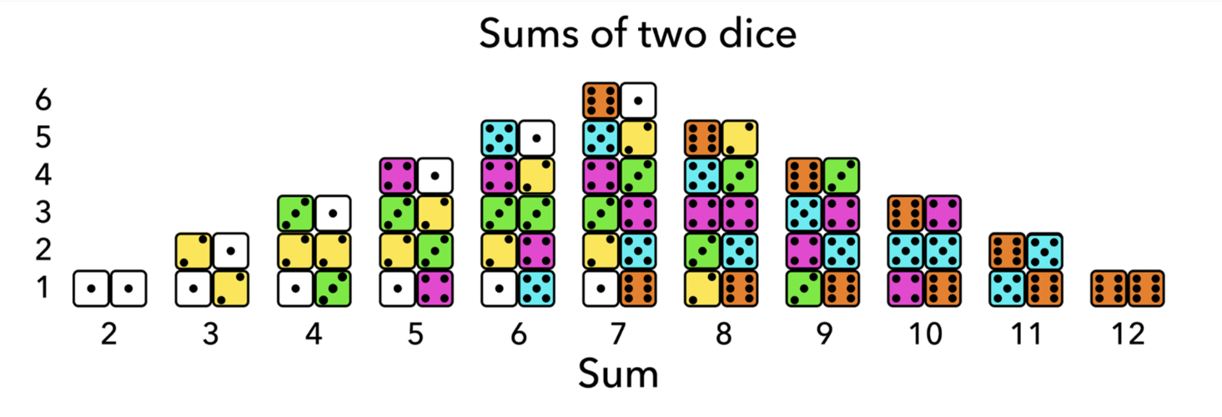

Summer temperature in the Northern Hemisphere

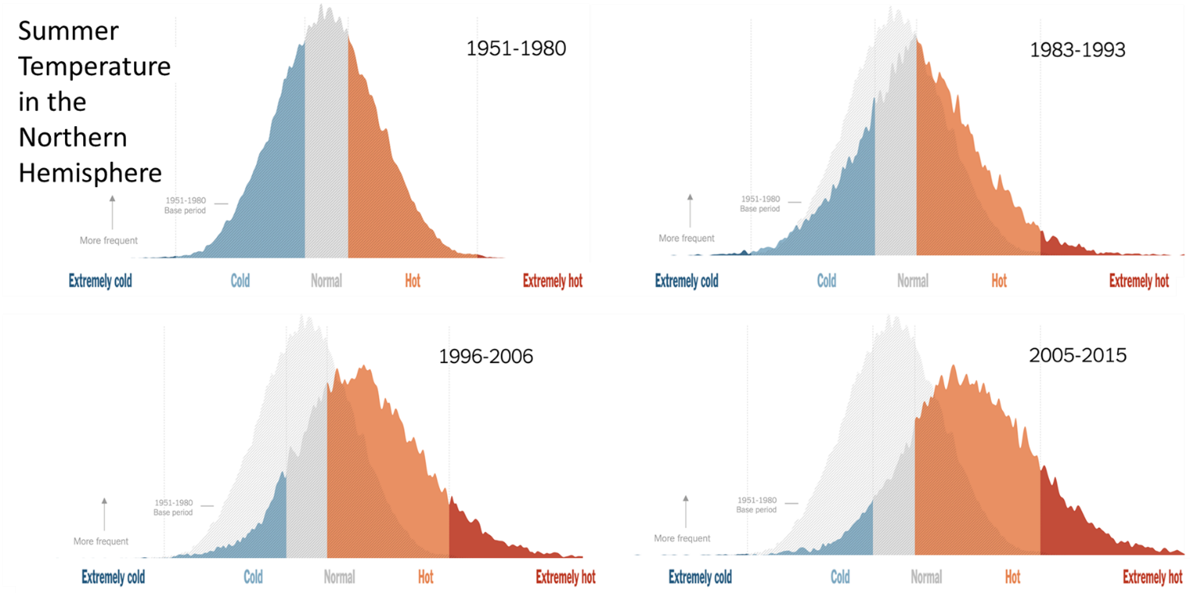

Appendix 4 – Rock, paper, scissors
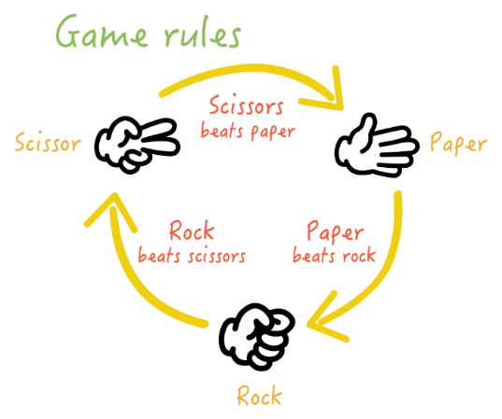
Printable version of diagrams of diagrams on slides 14 and 15

