Workshop 3:
Socially just approaches to problem solving in mathematics
This is one of a series of professional development workshops on promoting socially just mathematics teaching developed by the members of the Teaching Maths for Social Justice Network (TMSJN) and freely available via the network’s website: www.mathsocialjustice.org
The development of this workshop was supported by funding from the BERA Small Grant Fund awarded to Pete Wright and a team of co-researchers from the TMSJN.

Guidance notes for facilitators
These guidance notes are written to accompany the ‘Socially just approaches to problem solving in mathematics’ PowerPoint presentation available on the TMSJN website. They are designed to support a facilitator in leading a workshop with a group of teachers. The guidance notes are both detailed and flexible, which means they are suitable for a range of facilitators, including the experienced teacher educator working with a group of student teachers, to a teacher with a particular interest in mathematics and social justice who wishes to run a professional development session for other teachers in their department or school. Some (but not all) of the notes are duplicated in the notes accompanying each slide within the PowerPoint presentation.

Session design:
- The session is designed to be a workshop lasting approximately 90 minutes in which participants are encouraged to play an active role by sharing and discussing ideas.
- It is aimed at teachers of mathematics across primary and secondary phases, including student teachers and experienced teachers engaging with the ideas for the first time (although facilitators may need to tailor the workshop to the needs of their participants).
- It draws on design principles agreed at a Critical Mathematics Education Working Group meeting held at the BSRLM conference in June 2024 including the following:
  - Facilitate critical reflection on practice through challenging discourses.
  - Support teachers in putting socially just maths teaching ideas into practice.
- The activities are an important aspect of the workshop as they provide an opportunity to link theory, critical reflection and practice. Facilitators should think carefully about how to model socially just practice when introducing the activities and be ready to highlight the characteristics of the activities that help to facilitate socially just teaching. Allow participants sufficient time to engage with the activities (to inform discussion) whilst ensuring there is also enough time allocated to the reflective discussions.

Resources:
- Tables arranged in café style to encourage small group and whole group discussion.
- Accompanying PowerPoint presentation (projected onto screen).
- Appendices 1 and 2 provide printable versions of the activities on slides 8 and 14 (useful for accessibility/visibility and to allow participants to annotate diagrams).
- It would be beneficial for participants to have access to the ILO Child Labour Report.
- If you are working with a group of teachers over a sustained period, you might want to get them to engage with some of Gutstein’s readings before the workshop: https://www.researchgate.net/profile/Eric-Gutstein

Introduction:
- Emphasise that this workshop, and others in the series, are free to download - they are accompanied by detailed/flexible notes for facilitators [slide1].
- Outline features of the workshop [slide 2].

Initial discussions:
- Discussion on slide 3:
  - Encourage participants to write down their own ideas first, then take some feedback.
  - Keep discussion brief (5 minutes or so), just as a 'warm up’.
  - The reflective discussion on slide 18 will encourage participants to refer back to the notes they record here.
  - Note the following terms are also considered to relate closely to what we mean by ‘problem solving’: real world contexts, investigations, modelling, meaningful experiences, problem posing.
- Reading and writing the world with mathematics [slide 4]:
  - Invite individual comments on the quotes.
  - Keep the discussion brief – enough to highlight key ideas.
  - Emphasise that these quotes offer a particular perspective to prompt discussion and are not meant to be a definitive answer.
- Gutstein’s (2006) framework for TMSJ [slide 5]:
  - Discuss in small groups then take some feedback.
  - This framework will be used to reflect on the activities presented in this workshop.

Classroom activities (part 1):
- Activity 1: If the world were a village [slide 6]:
  - We suggest that you use this activity to highlight the different ways that ‘problem solving’ could be interpreted/approached:
    - In a closed, procedural way (initially) – is this really ‘problem solving’?
    - Followed up with an approach highlighting how many of the TMSJ principles could be incorporated.
  - If you have the book, you could choose one double-page spread as an example to share.
  - Introduce the idea as presented in the Nrich activity (text in left hand column): https://nrich.maths.org/problems/if-world-were-village
- Where do people in the village come from? [slide 7]:
  - You could ask questions about percentages, more than/less than, ratios.
  - Note that all of these questions are closed and could be answered without really engaging with the context.
  - This is what some people consider to be ‘problem solving’. However, from Gutstein’s social justice perspective, this is not ‘problem solving’.
  - Questions that might lead to socially-just problem solving include:
Does this surprise you? Why do you think this is the case?
- The focus now moves on to more socially just approaches to problem solving.
- Where do people in the village come from? [slide 8]:
  - There is a printable version of slide 8 in Appendix 1 of the facilitators’ notes.
  - Get participants to have a go at this activity in small groups. Encourage collaboration and discussion.
  - Here are the accompanying questions from the Nrich task:
    - What do you think? All of them show exactly the same information.
    - Which representation makes you realise that there are 100 people?
    - Which one makes you realise that there are LOADS more people from Asia than anywhere else
    - Which was easiest to count? Did you notice how a flag had been used because that was linked to the topic?
  - The following video provides a useful way of introducing the activity: https://www.youtube.com/watch?v=A3nllBT9ACg
- Some more ideas from the Nrich activity [slide 9]:
  - Discuss how this approach is different to the closed questions on slide 7.
- Teachers’ notes accompanying Nrich activity [slide 10]:
  - Discuss how you might use/adapt this approach with your own students.
  - Other ideas for developing the activity include:
    - Prompt a discussion around equality and inequality
    - Consider how to write the numbers 6.7 billion and 67 million
    - The population has since increased – what is it now?
    - A class is normally around 30 children – relate the proportion of the village (percentages) to the equivalent proportion of the class (imagine a village of 30 people).
    - Further ideas available in Cotton, Jagdev, Kaur & Wright (2024): Towards a socially just mathematics curriculum (see page 99).
    - How else might you adapt the task for use with secondary school students?
  - You might want to discuss the cultural sensitivity of some of the questions, e.g. asking about owning TVs/cars may be seen as promoting a consumerist culture.

Mid-way reflections:
- Reflect on ‘If the world were a village’ activity [slide 11]:
  - Discuss in small groups and then as a whole group
- Challenging dogmas [slide 12]:
  - Relate back to the previous discussions.
  - Note the third and fifth dogmas were felt the most relevant to this workshop, whilst others were felt more appropriate for the other two workshops.
  - Encourage participants to start with dogmas 3 and 5 before moving onto any of the other three dogmas they feel are relevant.

Classroom activities (part 2):
- Activity 2: Exploring child labour [slide 13]:
  - This activity looks at how students can be encouraged to explore a social justice issue through adopting a problem-solving approach.
  - The reflection will focus on the problem-solving approach.
  - The way the activity is presented is more suitable for secondary age students, however the approach can be adapted for primary students and other social justice issues can be used as a focus.
  - We have chosen ‘child labour’ as it is easily relatable to students’ own lived experiences.
- The UNICEF report provides a useful starting prompt: https://www.ilo.org/sites/default/files/wcmsp5/groups/public/@ed_norm/@ipec/documents/publication/wcms_797515.pdf
  - The discussion on slide 13 would be informed by the facilitator being familiar with the UNICEF report – you could relate the discussion to the meaning assigned to ‘child labour’ in the report, e.g. you might consider exemptions (such as domestic chores) – emphasise the subjective nature of the definition.
  - You could also show some of the images from the report.
  - The report (p.18) defines ‘child labour’ as “work that children are too young to perform and/or work that, by its nature or circumstances, is likely to harm children’s health, safety or morals”. It goes on to provide more technical definitions.
- It may be worth highlighting how child labour is a worldwide issue (whilst the pictures illustrate only African and Asian contexts) – you could highlight ‘Western’ contexts such as the extent to which child actors might be considered as exploited in the visual media.
- Discussion prompts [slide 14]:
  - There is a printable version of slide 14 in Appendix 2 of the facilitators’ notes.
  - Encourage participants to describe the features of the graphs (line graphs/bar charts/numerical data.
  - Describe any interesting features, e.g. percentage of children in labour remains at 9.6% between 2016 and 2020 and yet number increases (why?)
  - Prompt questions for discussion:
    - Is this headline justified? Why?
    - Why do you think the data has been presented in this way?
    - Describe the mathematical features of the graphs? (scales, points, bars)
    - How are the lines related to the bars?
    - How else could the data have been presented?
    - Could different presentations lead to different conclusions?
  - Encourage a critical understanding by asking questions about the data:
    - What counts as ‘hazardous’?
    - How do people measure how many children are working?
    - How do people know how many children there are altogether?
    - How is a value for a given year arrived at? Averages?
    - Could you estimate the percentages/numbers in 4/8/12/16/20 years’ time? Give reasons for your estimates.
    - How confident are you that your prediction will come true? What would you need to know to be more confident?
  - Here are some other headlines suggested in the ILO/UNICEF report:
    - Child labour remains a persistent problem in the world today.
    - Global progress against child labour has stagnated since 2016.
    - The global picture masks continued progress against child labour in Asia and the Pacific, and Latin America and the Caribbean.
    - Continued progress was registered over the last four years among children aged 12 to 14 and 15 to 17.
    - The COVID-19 crisis threatens to further erode global progress against child labour unless urgent mitigation measures are taken.
    - Involvement in child labour is higher for boys than girls at all ages.
    - Child labour is much more common in rural areas.
    - Most child labour – for boys and girls alike – continues to occur in agriculture.
    - The largest share of child labour takes place within families.
    - Child labour is frequently associated with children being out of school.
- Next steps [slide 15]:
  - Encourage participants to think about how they would answer the questions on the slide.
  - Then discuss how they would use these questions with their students.
  - What is the rationale behind each question?
  - What challenges are involved in using them in the classroom?
  - How could you draw links between child labour worldwide and students’ own experiences?

Final reflections:
- A problem-solving approach to exploring a social justice issue using mathematics
[slide 16]:
  - Discuss how this approach has been modelled during the second activity.
- This provides an opportunity to discuss any concerns participants might have about tackling ‘controversial issues’ in the mathematics classroom.
  - There is a useful guide from Oxfam which might inform such a discussion: https://policy-practice.oxfam.org/resources/teaching-controversial-issues-a-guide-for-teachers-620473/
  - Whilst many teachers of mathematics may lack confidence in tackling controversial issues, it is important to encourage them not to shy away from doing so (otherwise the myth that mathematics is culture-free may be compounded).
- The TMSJN website includes two activities (Community in the classroom, Growth in earnings) that provide examples of how to facilitate exploring social justice issues: https://mathsocialjustice.org/activities/
- Reflect on ‘Exploring child labour’ activity [slide 17]:
  - Discuss in small groups and then as a whole group.
  - There is likely to be debate around the distinction between ‘reading’ and ‘writing’ the world with mathematics and the challenges involved in translating ideas around social justice into classroom actions.
  - Gutstein’s research demonstrates ways in which it is possible to do so.
- Reflective discussion [slide 18]:
  - The aim here is to identify ways in which participants’ thinking has moved on during the session by relating back to the initial discussion [see slide 3].
  - Encourage participants to refer back to any individual or collective notes that were taken.
- Discuss the ‘conceptualisation of TMSJ’ [slide 19]:
  - This conceptualisation was presented in the ‘Introduction to TMSJ’ workshop.
  - It can be a useful summary to take away and prompt future discussions and inform future work.
- The references used in the presentation are presented on slide 20.

Reflections from research team members on trialling the workshop:
Maya (pseudonym) reflects on trialling the workshop in a two-hour seminar for 10 PGDE secondary mathematics student teachers, following the second of three school placements.
- The workshop began by relating the ideas back to student teachers’ experiences of the placement they had just completed, providing a justification to engage with critical thinking around mathematics.
- Both activities were completed, as it was felt they provided complementary examples and experiences. Despite initial concerns that there would not be enough content to engage student teachers for the full two hours, in the end it was felt that even more time could have been devoted to the reflection parts of the workshop.
- The student teachers liked the first activity (‘If the world were a village’) and felt confident that they could go on to use it in the first years of secondary (despite it being an activity designed for primary school). They felt some of the statistics could prompt debate amongst adults and children alike.
- There was some concern expressed by student teachers beforehand about tackling ‘controversial issues’ (such as ‘child labour’) in the mathematics classroom. They were encouraged to compare with some existing literature on tackling issues in ‘modern studies’ lessons.
- Student teachers enjoyed the opportunity to engage with the question ‘What is child labour?’ and this led to an interesting debate. The ILO report provided useful information to engage with the debate.
- Student teachers had used Schoenfeld’s Teaching for Robust Understanding (TRU) framework in previous seminars and had considered its relationship with social justice (in particular, ‘inequitable access to content’, ‘agency/ownership/identity’). They appreciated the opportunity the workshop provided to make connections to another framework (Gutstein).
- With hindsight, more attention might have been paid to Gutstein’s framework, perhaps providing an opportunity for student teachers to read about it beforehand.
- Student teachers were encouraged at the end of the workshop to explore links between socially-just mathematics teaching and official policies, which were seen as providing legitimacy for trying out some of the ideas. They identified opportunities within Curriculum for Excellence (Scotland’s curriculum), including references to ‘responsible citizens’, ‘learning for sustainability’, ‘inter-disciplinary learning’, as well as a clear focus on social justice within the Standards for Provisional Registration.
- After the workshop, some students expressed confidence in incorporating the activities into lessons on their final placement. One participant described the workshop as a ‘breath of fresh air’ demonstrating how much participants appreciated the opportunity to look at teaching mathematics from a different perspective.
Balbir Kaur (University of Nottingham) reflects on trialling the workshop (along with some other members of the research team) with delegates (mostly teachers of mathematics) at a recent conference.
- As participants had chosen this workshop from several on offer, they tended to have a greater pre-existing interest in socially just mathematics teaching than ‘typical’ teachers. This meant that there was generally a high level of engagement in the discussions.
- The workshop provided opportunities to identify clear links between participants’ feedback from the activities they tried out and the reflective discussions they engaged in, including around ‘what is problems solving?’ and Gutstein’s framework.
- The open nature of the ‘If the world were a village’ task (which involved discussing different ways of representing the data), along with other discussion prompts, led to rich and insightful discussions. It should be noted that the workshop provided opportunities for the facilitator to learn/benefit as much from the discussions as the participants.

Appendix 1 – Where do people in the village come from?
Printable version of slide 8
- How will you represent this data for maximum effect?
- Give reasons for your answers
Region | Population
Asia | 61
Africa | 13
Europe | 12
South America, Central America and the Caribbean | 8
Canada and United States | 5
Oceania | 1


Like this …?


… or like this …?

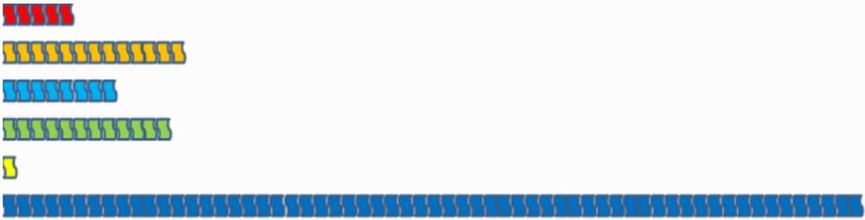
… or like this …?

… or in a different way?

Appendix 2 – Discussion prompts Printable version of slide 14
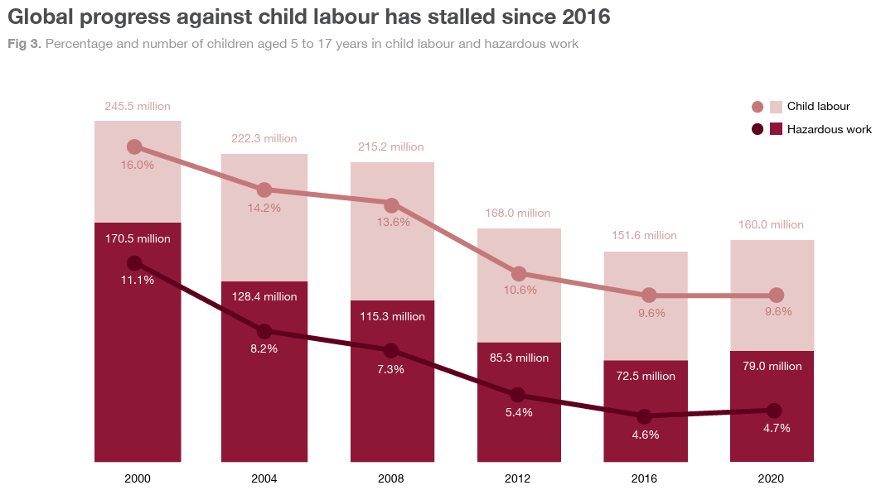
Source: Child Labour report (ILO, UNICEF, 2021)
- What do you notice about the graphs?
- What other headlines could you suggest?
- What questions do you have about the data?

